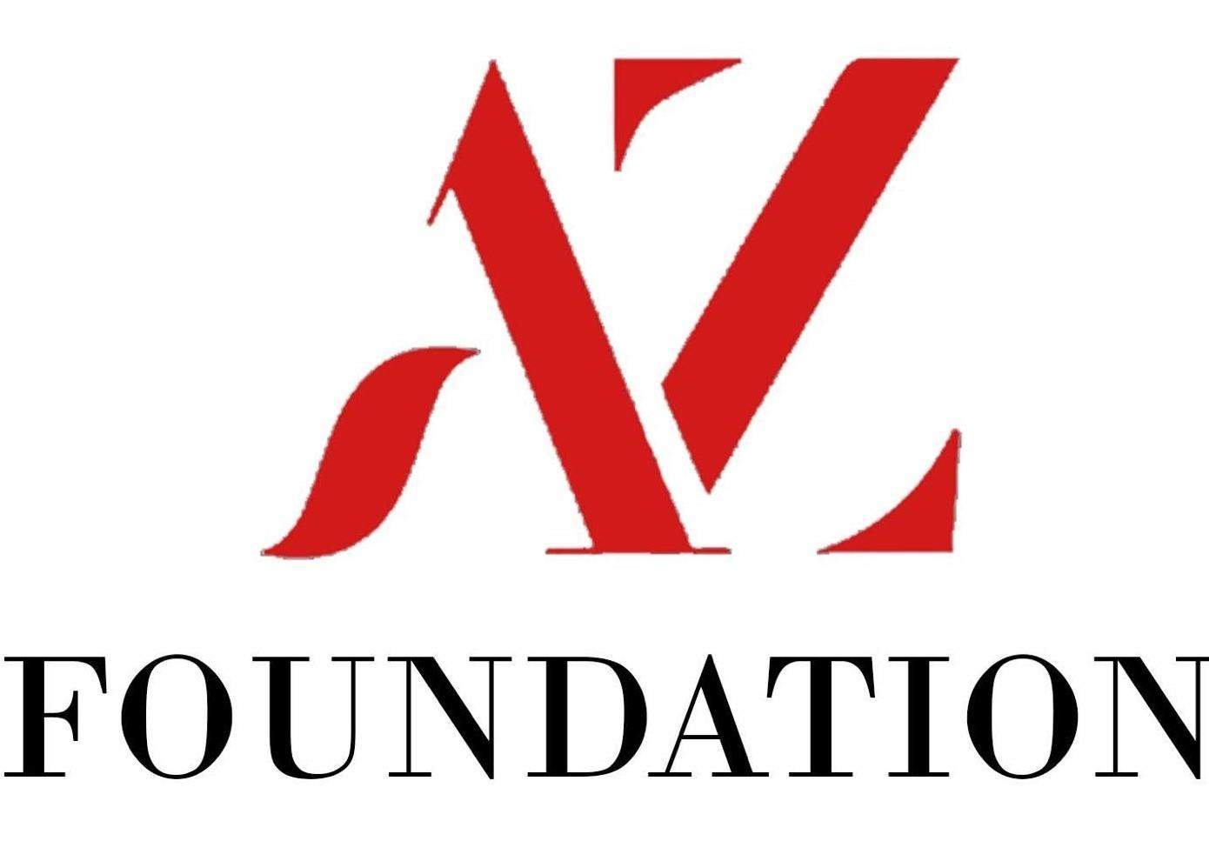

4th Annual Golf Tournament: May 20, 2024
Awards, Prizes, Raffles & Silent Auction
Blissful Meadows Golf Course, 801 Chocolog Rd., Uxbridge MA

8:00 AM Registration
8:45 AM Announcements/Tournament Info
9:00 AM Shotgun Start- “Scramble” Format

Golf Participants: $150 Player, $600 Foursome
Includes golf, cart, gift and dinner
Dinner Only Guests: $50.00/person
For questions, please contact:
Joe Zenus: dzenus@aol.com or Paul Tamagni: tamagnip@gmail.com
Make checks payable to:
The Aaron Zenus Foundation
P.O. Box 16, Milford, MA 01757
Golf Registration/Payment and Hole Sponsorship* Deadline is April 15th, 2023
Player’s Name | E-mail | Phone | Shirt Size
Dinner Only Names Total # of Tickets
*Hole Sponsorship $150.00: Sponsor name listed on signage at a hole on the course.
We are an approved 501(c)3 tax-exempt organization Tax I.D. #84-1954443

